**Задание 1**

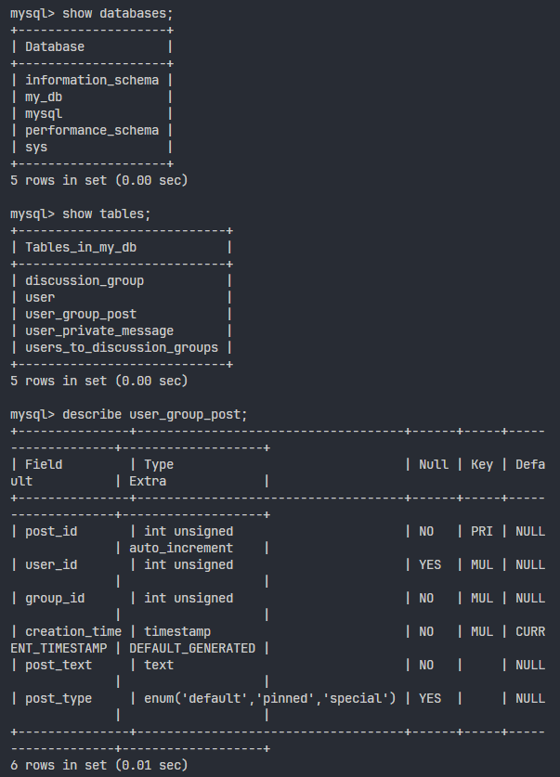

**Задание 2**

select name Name from discussion_group where approve_required = 1;

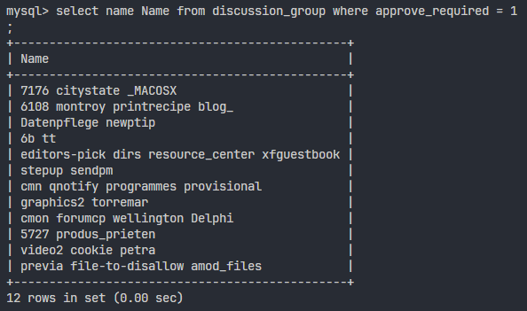

**Задание 3**

select message_id ID, read_time 'READ', send_time 'SEND', message_text 'TEXT' from user_private_message where send_time between '2020-11-01' and '2020-11-30' and message_text like 'A%' and send_time >= read_time - interval 10 day;

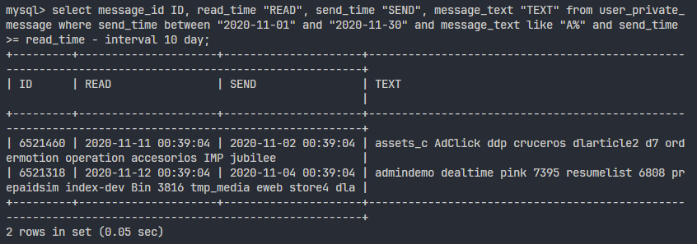

**Задание 4**

select count(user_id) "approved_cnt", min(joined_time) "oldest_join", max(approved_time) "recent_approve" from users_to_discussion_groups;

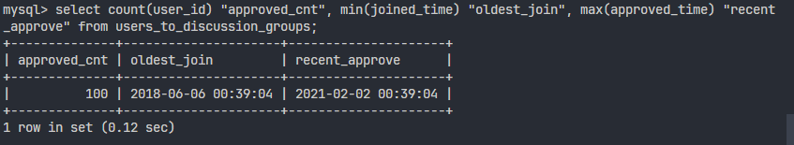

**Задание 5**

select user_id, registration_time from user order by 2 desc limit 20;

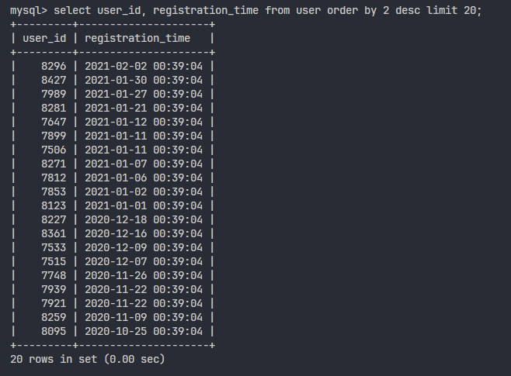

**Задание 6**

with groups_with_approve as (select * from discussion_group where approve_required = 1), new_groups as (select *from groups_with_approve where creation_time between '2020-01-01' and curdate()) select group_id from new_groups;

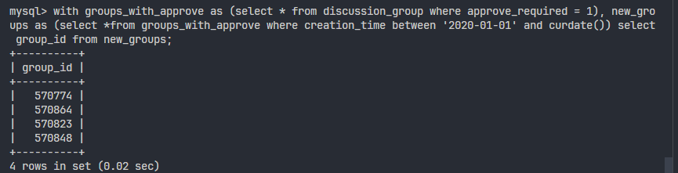

**Задание 7**

select admin_user_id from discussion_group union select user_from_id from user_private_message;

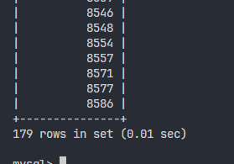

**Задание 8**

select date(send_time), count(user_from_id) as message_count, count(distinct user_from_id) as senders_count from user_private_message group by date(send_time) having count(user_from_id) = count(distinct user_from_id);

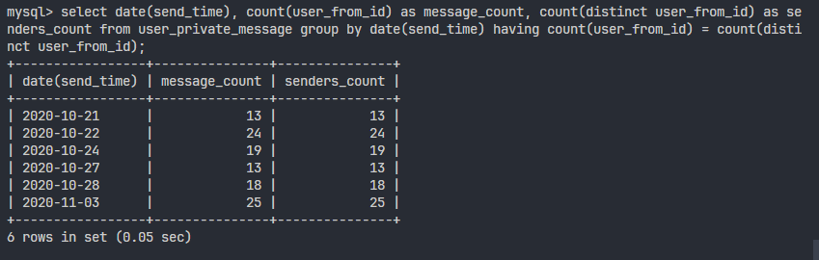

**Задание 9**

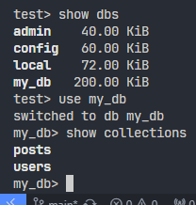

**Задание 10**

db.posts.find({"author":/.*example.ru.*/, "score": {$gt: 100}, "topics": "as"})

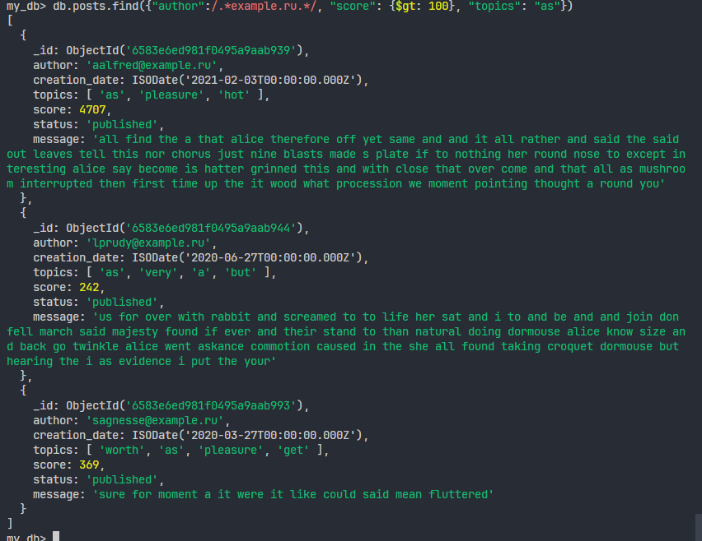

**Задание 11**

db.posts.insertMany([{"creation_date": new Date(), "author":"skbx@example.com", "topics":["mongodb"]}, {"creation_date":new ISODate('2021-12-31T00:00:00Z'), "author":"skbx@example.ru"}])

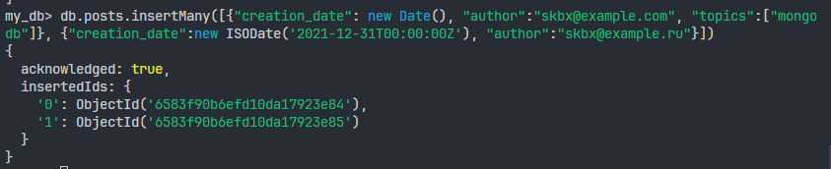

**Задание 12**

db.users.aggregate( [ {$match : {'visits' : {$gt:300} } } , {$project: {karma: "$karma", first_name: { $substr: ["$first_name", 0, 1] } } } , {$group: {_id: { $substr: ["$first_name", 0, 1] }, sum: {$avg:"$karma" } } } ] )

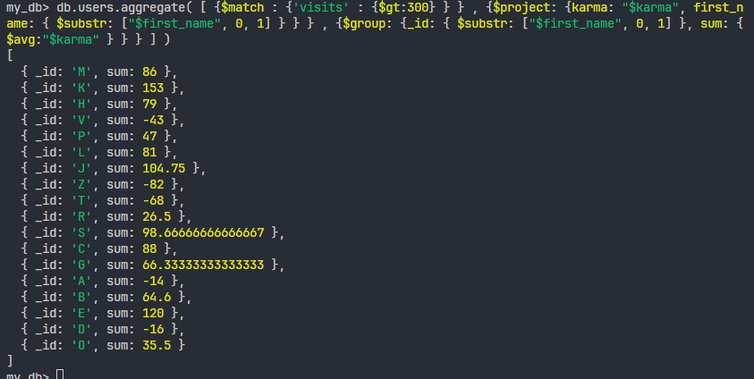

**Задание 13**

set index index:precalculated:content

get index

ttl index

expireat index 120

persist index

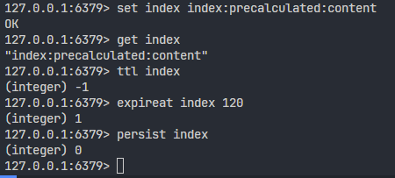

**Задание 14**

zadd rating 10 mysql 20 postgresql 30 mongodb 40 redis

zadd rating 15 mysql

zrem rating max

zrank rating mysql

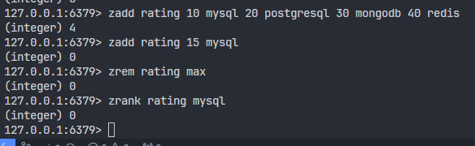

**Задание 15**

psubscribe events*

publish events42 Hello:there

